I²C Port
The I²C port can be written to and read from using the diagnostics. In addition, the development kit has some I²C peripherals on board. The diagnostics give you the ability to control them as well.
This is accomplished using the following QuickUSB Library functions:
QuickUsbWriteI2C - Writes a block of binary data to the I²C port.
QuickUsbReadI2C - Reads a block of binary data from the I²C port.
The I²C tab is shown below:
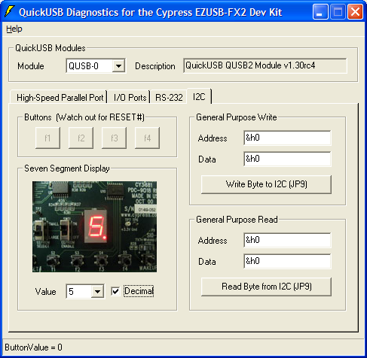

Buttons
The buttons display the state of the four pushbuttons on the bottom section of the board.

Seven Segment Display
Displays the current state of the seven segment display.

Value
A combobox which is used to change the value shown on the seven-segment display.

Decimal
A checkbox to change the state of the decimal on the seven segment display.

